**Exercise**1.  
 i)  
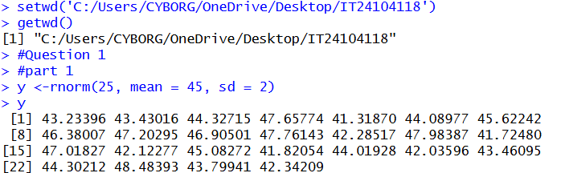

ii)   
